ACS-2814-002
Lab #7

Submit your responses to the questions below via an email to: yc9579@gmail.com

Download the Lab6 database from http://ion.uwinnipeg.ca/~ychen2/access2814/Lab6.accdb and develop the following queries:

Query1
List the name of the category that represents the most quantity of products sold overall.

Query2
List those provinces where there are no stores.

Query3
Create a list of employees and the store that they work at.

Query4
Develop a query that is equivalent to the following SQL:

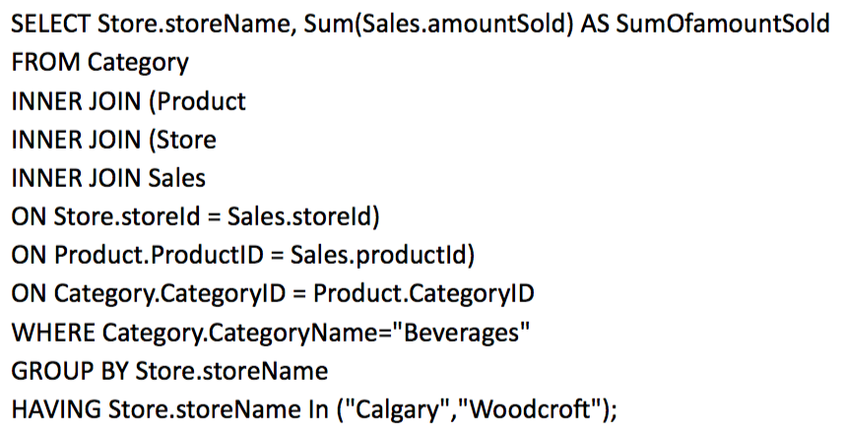
Result:
storeName | sumOfamountSold
Calgary | $7.00
Woodcroft | $48.00

Query5 (do not do this since this part of contents has not been discussed yet. This will not impact the evaluation.)
Write a query in SQL that increases the unit price of all products by 5%. This would result in a permanent change to the Products table.

