Sample Questions - from Previous Examinations

- What do the following acronyms stand for?

ERD __Entity-Relationship Diagram___________________

OLTP _On-Line Transaction Processing________________

- Define the term referential integrity.

- Consider two relation schemas R₁ and R₂;
- The attributes in FK (foreign key) in R₁ have the same domain(s) as the primary key attributes PK (primary key) in R₂; the attributes FK are said to reference or refer to the relation R₂.
- A value of FK in a tuple (record) t₁ of the current state r(R₁) either occurs as a value of PK for some tuple t₂ in the current state r(R₂) or is null. In the former case, we have t₁[FK] = t₂[PK], and we say that the tuple t₁ references or refers to the tuple t₂.

- Consider two tables X and A; they have the following structure:

X
x | y

A
a | b | z | x1 | x2

The attributes x1 and x2 are foreign keys for two one-to-many relationships between A and X. Attribute z, implements a one-to-one relationship between A and X.
Team
Show the MS Access Relationships Tool diagram that needs to be drawn so that Access will enforce referential integrity for the relationships.

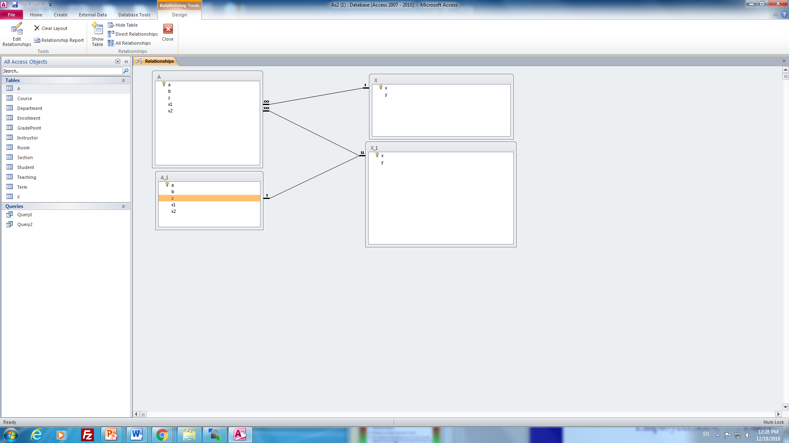

- The following ERD represents a model for a sports league where games are played and the results are recorded.
plays
as home
plays
as visitor
1
1
N

GameNo

TeamNo
Game
GameDate

Team

N
GameHomePoints
TeamName
GameVisitPoints

- Map the ERD to a relational database and show the relations to be created.
- What must be done to ensure the mandatory relationships are enforced by MS Access?
- Show the contents of your relations if:
- the Goldeyes (home team) play against the Moose (visiting team) on Jan 1, 1991, and the Goldeyes win 10 to 5
- the Moose (home team) play against the Goldeyes (visiting team) on Dec 31, 1999, and the Moose win 6 to 1
Book
- the Goldeyes (home team) play against the Bombers (visiting team) and the Goldeyes win 7 to 2
You can choose the values you want for TeamNo and GameNo.

- Game(GameNo, GameDate, GameHomePoints, gameVisitPoints, play_as_home, play_as_visitor)
Team(TeamNo, TeamName)

- In order to implement the mandatory constraint, set ‘required’ property for both FK attributes: play_as_home, and play_as_visitor.

- populate data in both Game and Team tables.

- Consider the following ERD

author
title
book

CallNo

Map the ERD to a relational database and show the relation(s) to be created.

Book(CallNo, Title),
Author(book, author)

- Consider the following ERD for a library application. There are several books and several patrons (a patron is a person who borrows books). Over the course of time
- a book may be borrowed by one or more patrons
- a patron may borrow any number of books
- the same patron could even borrow the same book several times.
Each patron is identified by their patron id (Pid), and each Book is identified by its call number, CallNo.

M
N
CheckOutDate
ReturnDate

Pid

Bname
borrow
Patron
Book

Pname

CallNo

Map the ERD to a relational database and show the relation(s) to be created.

Patron(Pid, Pname),
Book(CallNo, Bname),
Borrow(Pid, CallNo, CheckOutdate, returndate)

- Construct an ERD for a parking lot system.
The company you are doing this for has many different parking lots. Each parking lot has a unique number ParkLotNo that identifies the lot, and other attributes such as the location of the lot. Each parking lot has a number of parking spaces; if a lot has n spaces, then they are numbered 1, 2, 3, …n. For each space there are three attributes: the rental cost, and two attributes indicating if there is a plug outlet and if the space is paved or not. The system needs to track information on parking lots and on parking spaces. Also, the system must keep track of who is renting the parking spaces. So they need to keep information on renters such as name, address, phone number, and they need to track the space (or spaces) each person is renting. Note that at any given point in time, there is only one renter for a certain space. However, over a period of time, a space may have several renters. So the rental of a space has a start date and an end date.
parkingLot
Renter
rent
N
M
pid
location
parkingSpace
has
N
1
plateNo.
name
startD
endD
sID
cost
plug
paved
address
phone

- Suppose we create a form for a table that has attributes:
Name – a text field
Status – an integer (1, 2, or 3) with meanings
1 junior
2 intermediate
3 advanced
Province – a text string that is either “MB” or “SK” or “AB”
Draw a picture to illustrate the appearance of the form if Name is represented in a text box, Status is represented by an option group, and Province is represented as a combo box. Assume each of these controls is accompanied with a suitable label.

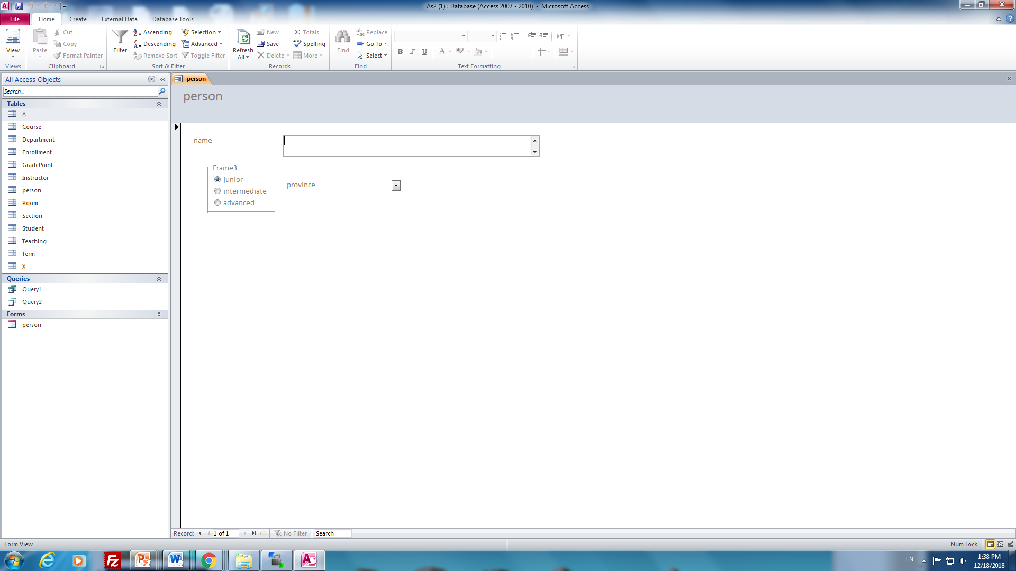

- Consider the following ERD. Map the ERD to a relational database showing the relation(s) that will be created.

DeptNo
phone

office
locn
Department

Department(DeptNo, locn),
phone(DeptNo, phone),
office(DeptNo, office).

- Consider the following ERD. Map the ERD to a relational database showing the relation(s) that will be created.
Fname
Lname
Initials

PerNo
PerBirthDate
Person
Name

Person(PerNo, Lname, Initials, Fname, PerBirthDate)

- What is the purpose of the Control Source property for a control on an MS Access form?

By the Control Source property, we indicate a column (in a table) associated with a control.

- Consider the following Vehicle table.

Vid | Make | Model | Colour | Kilos | Year | Price | Sold
1 | Toyota | Celica | Red | 100000 | 1994 | $15,000.00 | Yes
2 | Honda | Prelude | Blue | 150000 | 1994 | $18,000.00 | No
3 | Toyota | Celica | Red | 145000 | 1993 | $15,500.00 | Yes
4 | Honda | Prelude | Blue | 100000 | 1997 | $22,000.00 | Yes
5 | Toyota | Celica | Red | 100000 | 1996 | $15,000.00 | No
6 | Honda | Prelude | Blue | 150000 | 1996 | $18,000.00 | Yes
7 | Toyota | Celica | Red | 145000 | 1996 | $15,500.00 | Yes
8 | Honda | Prelude | Blue | 100000 | 1995 | $22,000.00 | No

- A business analyst would like to see the results of a query that shows how many vehicles were sold for each year. Design this query showing its definition in Design View.

- Another analyst wants a crosstab query illustrating how many vehicles there are for the various colours and years. Show the result (include row headings, column headings) of running such a query for the sample data.

a)

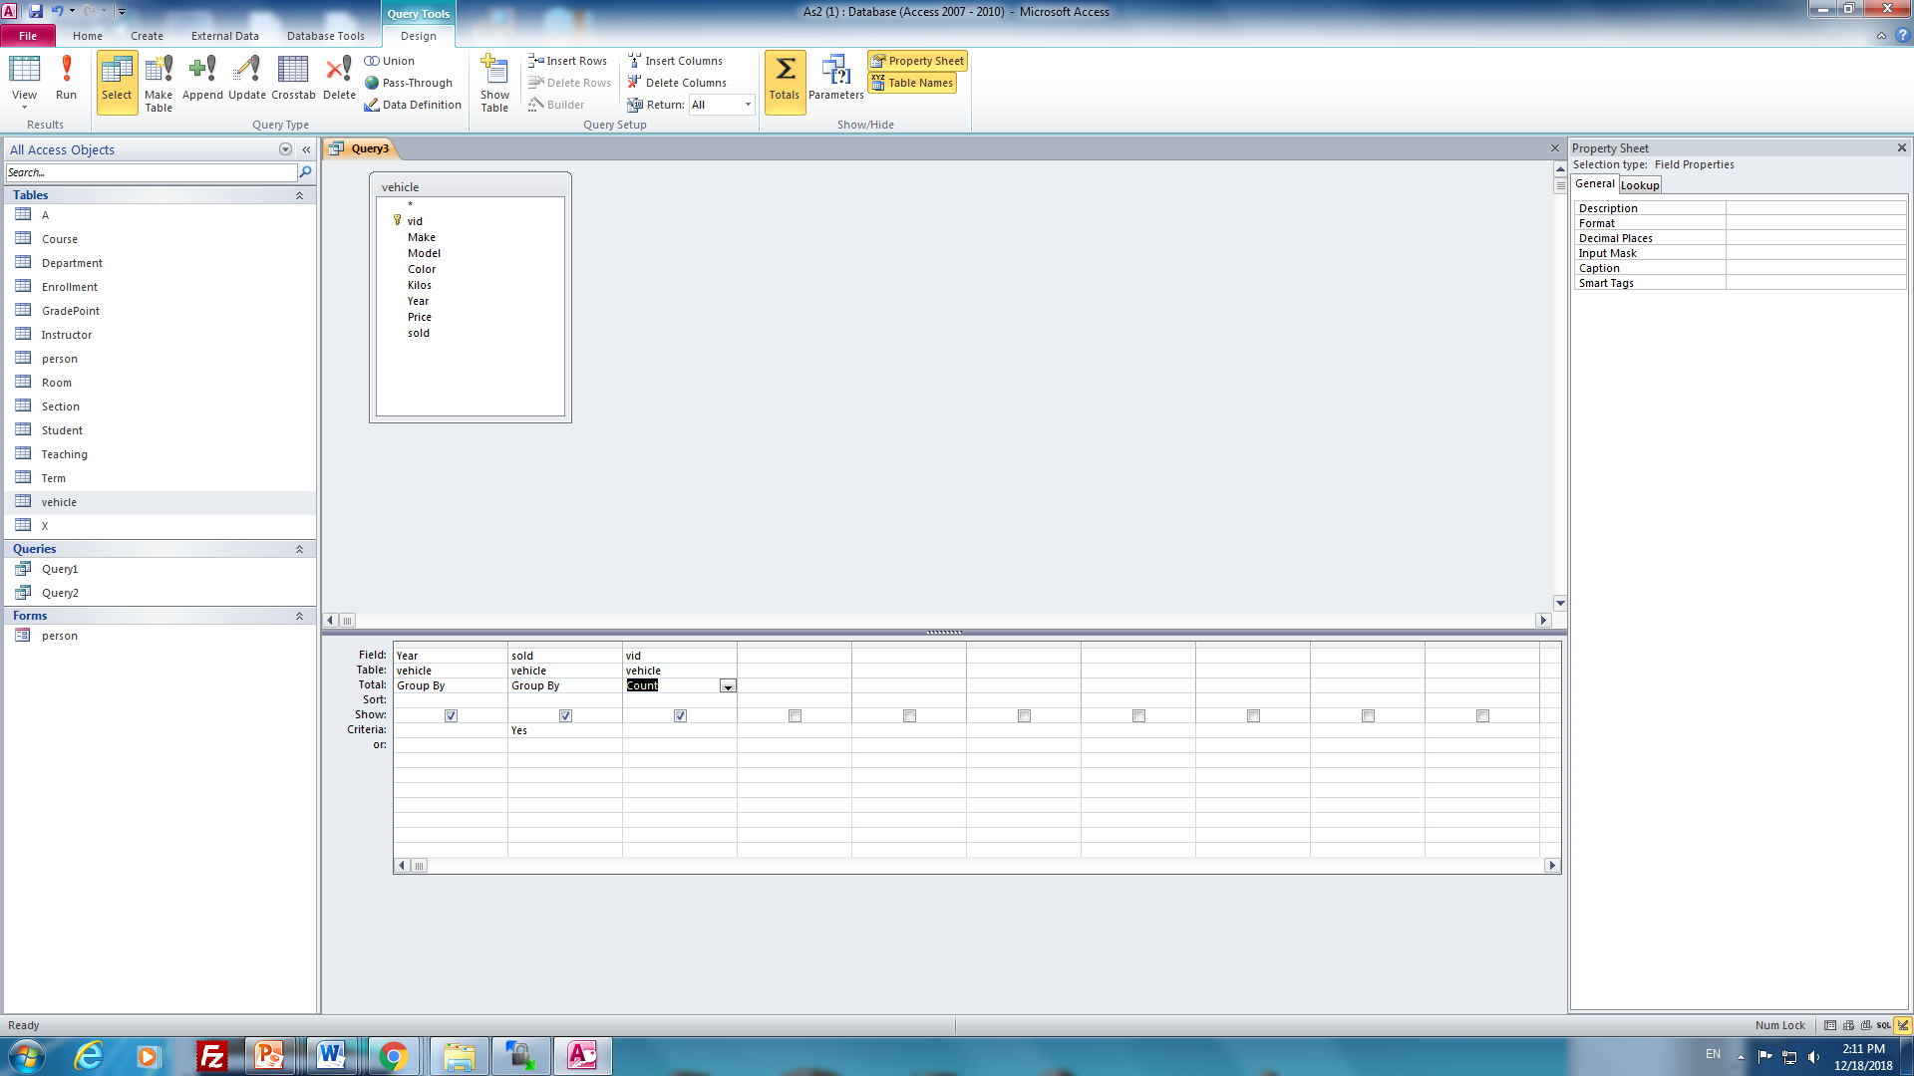

b)
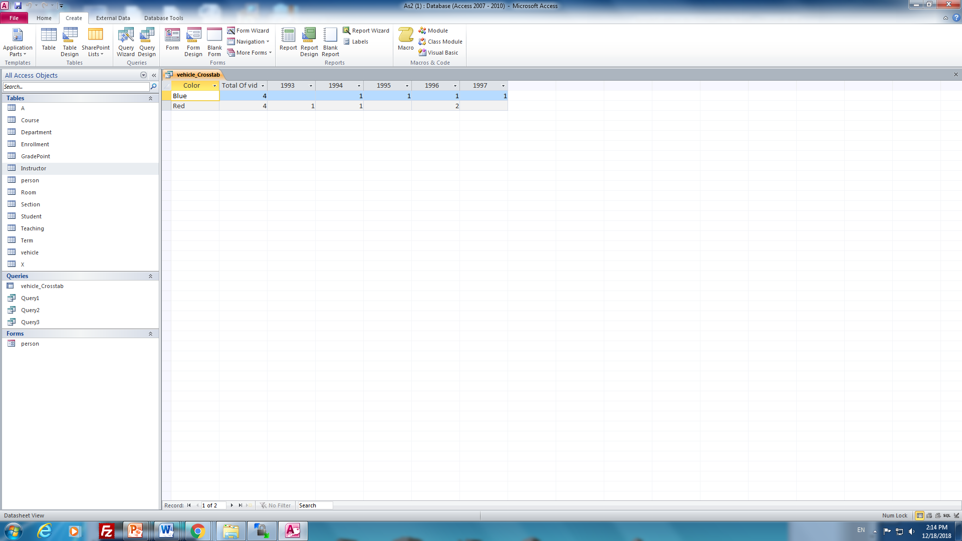

- Given the SQL statement below, show the corresponding Query Design View.
Use an attached sheet for your answer.
SELECT Auto.Make, Auto.Model, Auto.Year, Dealer.name
FROM Auto INNER JOIN Dealer
ON Auto.Did = Dealer.Did)
WHERE ( (Auto.Price) > 10000) );

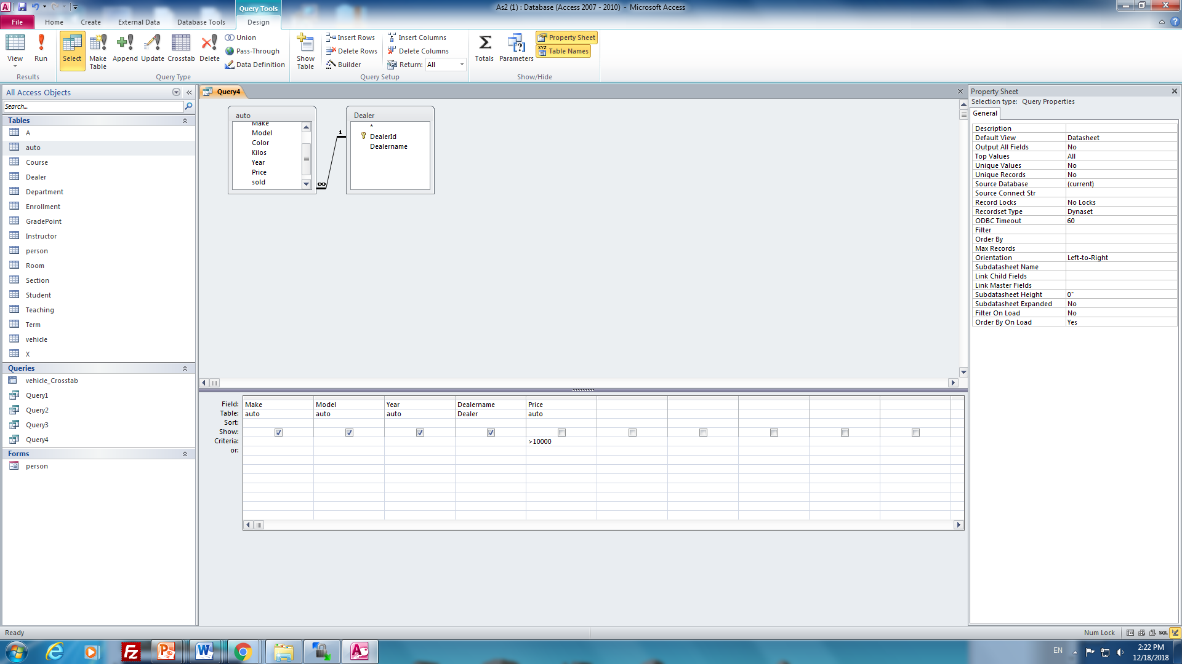

- Consider the following design.

Mid
Pid
MDate
Name

N
1
wife

Marriage
Person
N
husband
1

Map this ERD to a relational database, and show the table structures that must exist for this design.

Person(Pid, Name),
Marrigae(Mid, MDate, husband, wife)

- Consider the following ERD.

PCode

PNamew

PDesc

Product
1
Brand
N
N
1
Category

BDesc

BName

CatDesc

Cat

- Illustrate the relationships as they would be shown in the MS Access Relationships Tool.
- Show the relation structure created for Product when the ERD is mapped to a relational database.

a)
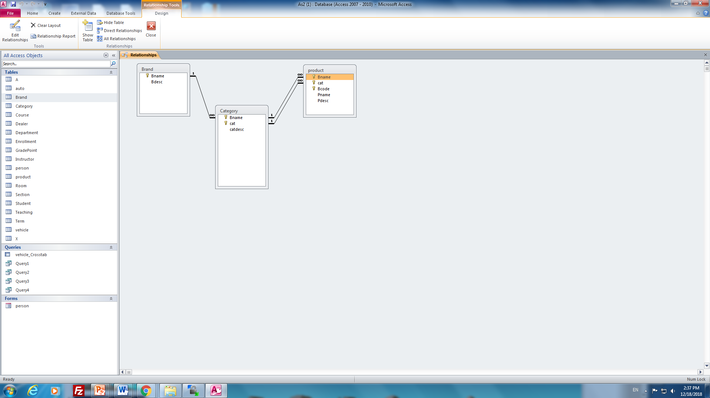

b) Brand(Bname, BDesc),
Category(BName, cat, CatDesc),

Product(BName, cat, Bcode, Pname, pdesc)

16.

Consider:
Dept#
DeptName
DeptPhone
DeptLocn

Assume the table is in 1NF.

List the candidate keys: DeptNam → Dept#
Dept# → DeptNam, DeptPhon, DeptLocn

Is the table in 2NF? _×_______
Is the table in 3NF? _×_______
Is the table in BCNF? _×_______

Consider:
StuGender
Student#
StuName
StuPhone
StuBirthDate

Assume the table is in 1NF.

List the candidate keys: Student# → StuName, StuPhone, StuBirthDate, StuGender

Is the table in 2NF? __×______
Is the table in 3NF? __×______
Is the table in BCNF? __×______

Consider:
Emp#
EmpName
EmpPhone
Dept#

Assume the table is in 1NF.

List the candidate keys: Emp# → EmpName, EmpPhone, Dept#

Is the table in 2NF? ___×_____
Is the table in 3NF? ___×_____
Is the table in BCNF? ___×_____

Consider:
Dept#
Emp#
EmpName
EmpPhone
DeptLocn

Assume the table is in 1NF.

List the candidate keys: Emp# → Empname, EmpPhone, DeptLocn, Dept#
Dept# → DeptLocn
If the table is not in BCNF, decompose the table into 2 or more tables so that each resulting table is in BCNF.
Is the table in 2NF? ____×____
Is the table in 3NF? ________
Is the table in BCNF? ________

Dept#
DeptName
DeptPhone
DeptLocn

DeptLocn
Dept#

Consider:
Dept#
DeptName
Chair
ChairName

Assume the table is in 1NF.

List the candidate keys: Dept# → DeptName, Chair, ChairName
DeptName → Dept#
Chair → ChairName
If the table is not in BCNF, decompose the table into 2 or more tables so that each resulting table is in BCNF.
Is the table in 2NF? _×_______
Is the table in 3NF? _×_______
Is the table in BCNF? _×_______

