ACS-2814-002
Lab #6

Submit your responses to the questions below via an email to:
yc9579@gmail.com

Consider the database of swimming lessons found by http://ion.uwinnipeg.ca/~ychen2/access2814/Lab3.accdb.

Relationship diagram:
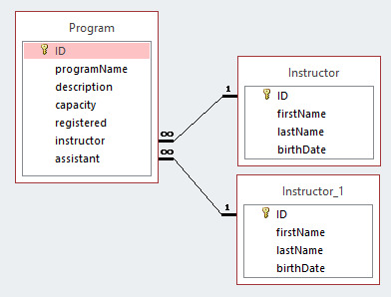

This database has two tables Program and Instructor. For each program there is a unique identifier, a description, an instructor, an assistant instructor, capacity, and the current registration. For each instructor there are ID, first name, last name, and birth date.

Develop the following five queries:
- Query1
List each program that has less than 5 participants registered.
- Query2
List each program that is not full; for such a program the number registered is less than the capacity.
- Query3
List the description of any program where the instructor’s last name is “Walker”.
- Query4
List the last name of the assistants for those programs where “Walker” is the last name of the instructor.
- Query5
List the last name of the assistant for programs where the instructor is “Walker” and where the course is not full.

