ACS-2814-002

Lab #2

Submit your responses to the questions below via an email to: yc9579@gmail.com

The following ERD represents a model for a hockey league.

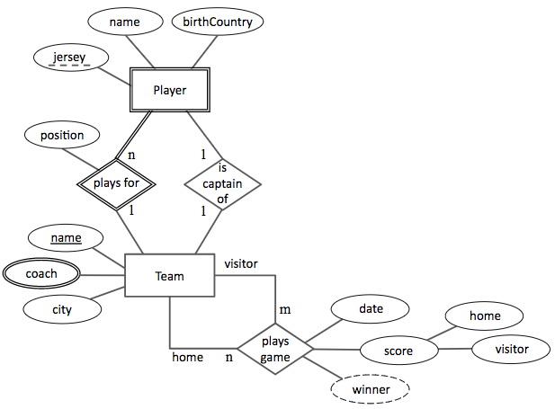

Map this ERD to a relational database. Show the relations that must exist for this design.

* On the Winnipeg Jets, Blake Wheeler (position RW jersey #26 from USA) is the captain, Canadian Mark Sheifele is #55 and plays C position, the coaches are Paul Maurice and Charlie Huddy
* Henrik Sedin (position C jersey #33 from Sweden) is the captain of the Vancouver Canucks, head coach is Travis Green
* The Jets beat the Canucks 1-0 in Winnipeg on January 21

For the purposes of this lab, use the ACS-2814 rules for mapping the ERD to a relational database, create the MS Access database (with PKs, FKs, and RI), and populate its tables with the data mentioned above.

______________________________________________________________

**EXTRA WORK: Do not submit**

Write the DDL that could create the relations for the ERD above.